WA-01
2016 IE Strategy Memorandum

Updated on 5/20/16




SUZAN DELBENE ROBERT SUTHERLAND
CoH: $820,580.34 CoH: $362
Date: 4/15/16 Date: 5/20/2016
Occupation: Congresswoman Occupation: Biochemist

SECTION I: Race Overview
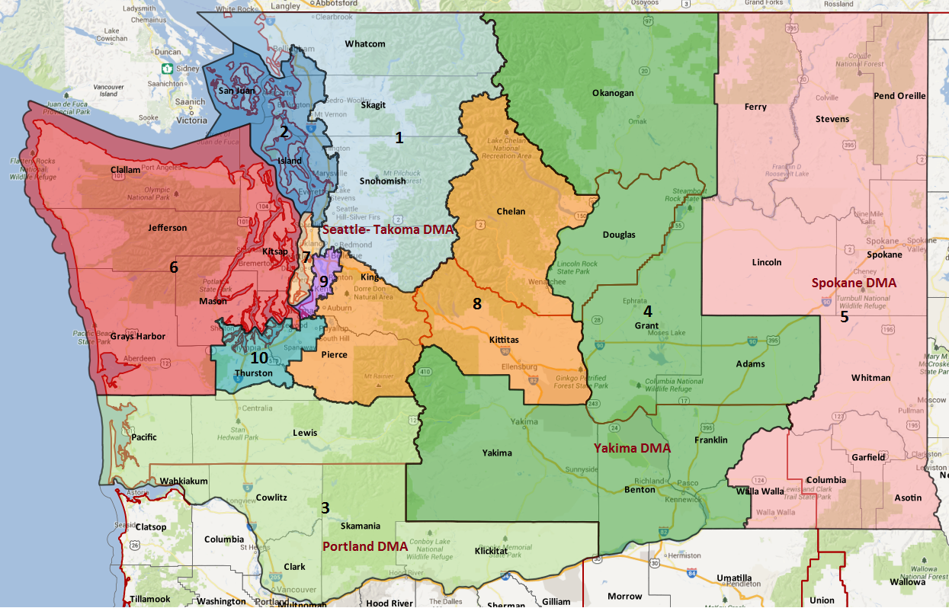

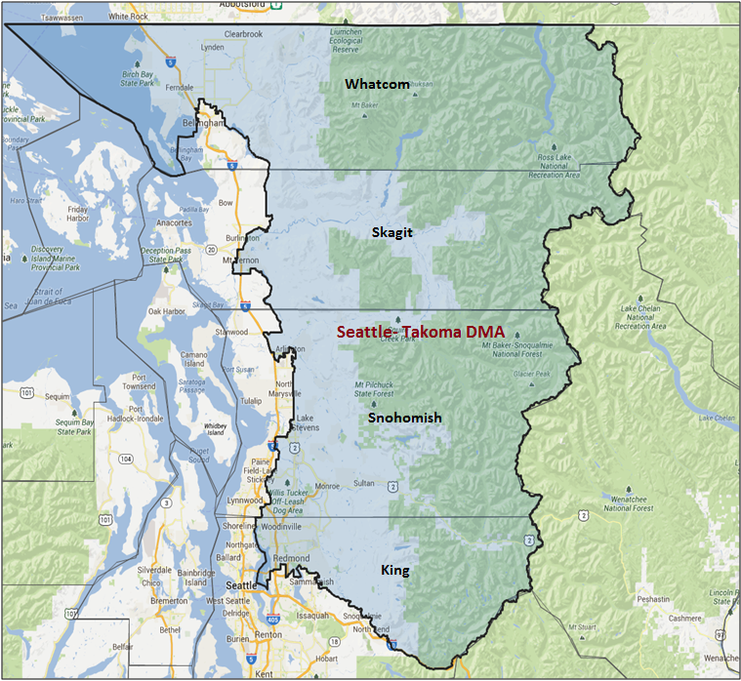

Media Market Costs

TV DMA | % of  CD | I.E.  35+ CPP | Cable CPP
SEATTLE | 100% | $319 | $480
WA-01 TOTALS: | 100.0%
Radio Landscape
DMA | Universe | CPP
Seattle | 1,597,700 | $420

Digital Landscape
  - Persuasion universe size: 67,253
  - Audience extension (key demos): Independents & Democrats, 30+
  - Weekly budget for full coverage: $18,225.63
  - Reach
    - YouTube - 331,563
    - Pandora - 243,699
Presidential Statistics

Cycle | Candidate | Party | Vote
2012 | Obama | DEM | 55.5%
2012 | Romney | REP | 44.4%
2008 | Obama | DEM | 57.2%
2008 | McCain | REP | 42.8%

Congressional Statistics
Cycle | W/L | Candidate | Party | Vote
2014 | W | DELBENE | DEM | 55.04%
2014 | L | CELIS | REP | 44.96%
2012 | W | DELBENE | DEM | 53.9%
2012 | L | KOSTER | REP | 46.1%

NCEC Data
Dem Performance: 51.5%
BVAP: 1.3%
Hispanic: 5.2%
Asian: 7.2%
Total Minority: 13.7%

Critical Dates
Filing Date: May 1st, 2016
Primary Date: August 2nd, 2016

Summary of 2014 Cycle Spending by Outside Groups
None

Summary of 2012 Cycle Spending by Outside Groups

TV Competitive Summary - Seattle
Campaign/Group | GRPs | Total Dollars
Koster/NRCC | 113 | $79,711
DCCC | 1,400 | $732,930
WA Education Assoc. PAC | 421 | $99,999
House Majority PAC | 1,000 | $382,065
Good Guys v Bad Guys | Total GRPs | Total Dollars
Good Guys | 2,821 | $1,214,994
Bad Guys | 113 | $ 79,711

Digital Media

The 2012 DCCC IE Program aired one advertisement over the internet (Spot 1) in WA-01 over the course of two weeks (10/2-10/15) for a total of ~156 GRPs at a client cost of $21,494.24. The digital buy in WA-01 was placed early and covered the entire district. The spot that aired online was the same spot that aired on Seattle Broadcast.

Note: Because we sensed the race was moving in our direction, we cut the last three weeks of the digital buy along with the last two weeks of broadcast television in WA-01.
Pre-Election Day Voting

Type of  “Early Voting” | Start Date  End Date | Percent of  Vote Cast Using this Method | Brief Description  (where/how  do people vote) | Timeframe (when does the majority of voting happen)
Early Vote | Oct. 10th – Nov. 8th |  | Can vote at “Accessible voting units” starting Oct. 10th
Vote By Mail | Oct. 10 – Nov. 8th |  | Ballots are mailed out starting the 10th and have to be received by board of elections by Nov. 8th

SECTION II: DISTRICT OVERVIEW

- District Overview and Data

  - Political Landscape
- DelBene was first elected in 2012 to complete Jay Inslee’s term who stepped down to run for governor.
- DelBene won her 2012 contest 53.9 – 46.1 and was one of the few democrats who increased their win margin from 2012 to 2016 and won 55-45.
- California State legislator Elizabeth Scott has filed to run as a republican against DelBene.
- DelBene has $820k on hand.

  - District Demographics
- Washington's 1st Congressional District is located in the northwestern portion of the state and includes Whatcom, Skagit and Snohomish Counties and part of King County.

- Cook Partisan Voting Index: D+4
- Urban Population: 7.1%
- Rural Population: 39.5%
- Suburb Population: 53.5%
- Median Income: $84,419
- Poverty Status: 4.7%
- Military Veterans: 10.4%
- Race/Ethnic Origin: 87.1% White; 1.3% African American; 7.2% Asian; 4.4% Hispanic

  - Electoral Context
- Senator Patty Murray is up for reelection in 2016. She was first elected in 1992. Her last election was in 2010 -- a rough year for Dems she won 52.4-47.6 and spent $2,342,472. She currently has $6,369,308 on hand. Cook currently has the race as solid D but Murray will spend on television, crowding the airwaves and raising the avg CPP.

  - Press Presence
- This district is 100% located in the Seattle media market which has a current issue price of $319 CPP.

Press Outlets include:
- Seattle PI
- KING5 TV
- Seattle Met
- Monroe Monitor
WA-01 Research

Suzan DelBene (Democratic Incumbent) Vulnerabilities

Suzan DelBene was first elected to Congress in 2012. She was previously an executive at Microsoft and helped to co-found drugstore.com and continued to work in the technology sector. DelBene attended Reed College and earned her MBA at the University of Washington. She rana against Dave Reichert in 2010 for the 8th district and lost but ran again successfully for the 1st district in 2012. She now serves the House Judiciary and Agriculture Committees.

DelBene was appointed to serve on President Obama’s Export Council, the President’s advisory committee on international trade. She also serves as co-chair of the New Democrat Coalition’s 21st Century Job Skills Working Group, and co-chair of the Women's High Tech Caucus, Internet of Things Caucus, Trademark Caucus, and Aluminum Caucus.

Top Vulnerabilities

- DelBene’s husband, former Microsoft executive Kurt DelBene was chosen to fix Healthcare.gov in the aftermath of the website’s failures
- Last cycle NRCC hit her for supposedly not paying her female staffers as much as her male staffers

Elizabeth Scott (Republican Challenger) Vulnerabilities

Elizabeth Scott, an educator by profession, is currently serving her second term in the Washington State House where she’s established a reputation as a Tea Party favorite as one of the chamber’s most conservative members.

Top Vulnerabilities

- Too extreme for the district
- Only legislator to vote against bill permitting criminal prosecution of spousal rape
- Sponsored anti-abortion bill declaring that life begins at conception
- Signed petition aimed at repealing law giving gay partners the same rights as married couples
- Voted against legislation supporting the Joint Center for Aerospace Technology Innovation, a major employer in her district
- Called for teachers to carry guns on campus

SECTION III: Appendix

- 2016 Campaign Side Consulting Team
Media:
Mail:
Polling:
Online/Digital:
Self-research:

